User Manual for Resekompanjon

# Startscreen

From the startscreen you can search for a trip by writing the origin (Från) and end (Till) locations, date and time for the journey. By pressing the green ”Sök” (Search) button the application will search for what you entered and show you to the search results.

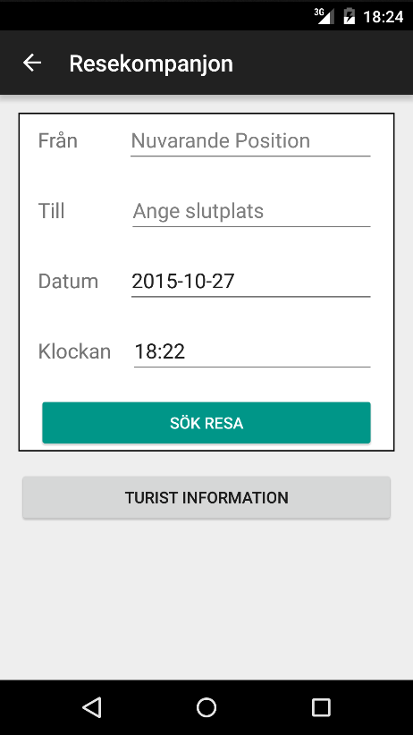

Figure Startscreen

# Search Results

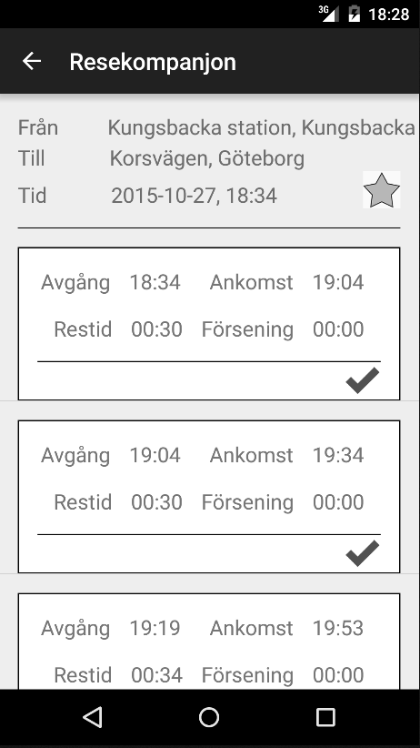

Figure , Search Result Screen

This screen shows all the results from what you searched for. It shows from which station you come from and to what station you want to get to. It also shows the time. If you press the star the journey will be added as a favourite. If you press it again, when it’s filled, it will be removed from your favourites. Each search result is shown as its own white box in a scrollable list. Each box contains information on when the vehicle leaves your start location and arrives at your end location in real time (including delays). It also shows how long the journey will take. If you press the grey checkbox-tick the journey that the tick belongs to will be added to your Planned Trips. That means you will receive a reminder for the journey (currently a few seconds after you’ve pressed the journey in the Planned Trips screen). Once again, when it’s green and you press it, the specific trip will be removed from your Planned Trips.

# Current Trip (Nuvarande Resa)

Show the current trip that you are “on”. You can press stop to make the bus stop at that specific bus stop.

# Favourites

The favourites screen shows all your saved trips. If you press at the side of a favourite trip it will search for a journey with that origin and destination but with the current time. The favourites can also be removed.

# Planned Trips

The planned trips view shows what trips you have planned. If you press at the side of a trip “box” you will be reminded in a few seconds that you have to go to the bus. You can also turn off and on the alarm.